Serial sectioning PSOCT-2P data processing Matlab code manual

Shuaibin Chang [shuaibin@bu.edu](mailto:shuaibin@bu.edu)

Jiarui Yang [jryang@bu.edu](mailto:jryang@bu.edu)

Written on 09/16/2020

The manual is separated into the following sections:

* Introduction
* Generic parameters input
* Multi-thread processing with BU SCC
* Distortion correction
* Surface profiling
* Optical property fitting
* AIP, MIP calculation and saving
* 2D images stitching
* 3D volumes stitching
* Vessel segmentation
* How to run them?

1. **Introduction**

Data processing is integrated into customized MATLAB code: Recon_2P.m, *OCT_recon.m,* while various functions including distortion correction, surface profiling, optical fitting, 2D images stitching and 3D volume stitching are packaged into individual MATLAB files.

1. **Generic parameters input**

Before running the code, a few parameters should be specified, some of them should be changed according to how the sample was imaged, like total #slices, #tiles per slice, file paths etc.

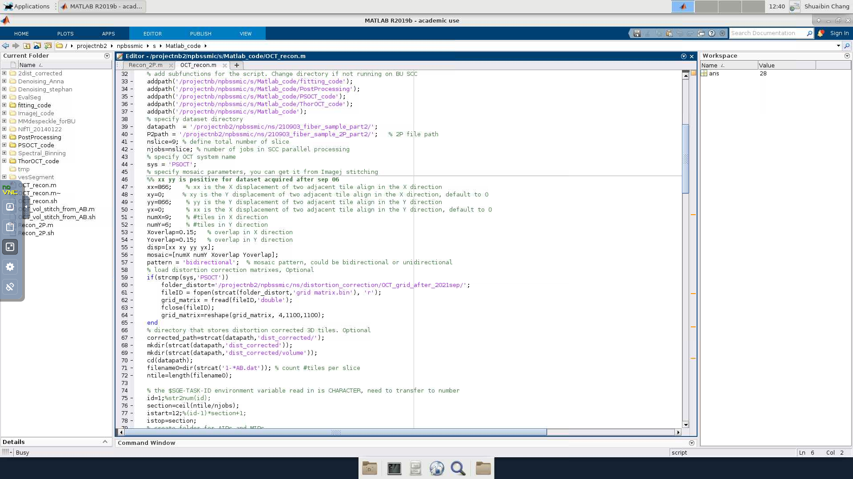

Load grid distortion correction matrix, leave unchanged unless alignment is changed

System and mosaic param, change numX, numY for each sample

SCC parallel processing part

OCT and 2P file path, #slices, change for each sample

OCT and 2P file path, change for each sample

Add matlab code paths

Add matlab code paths

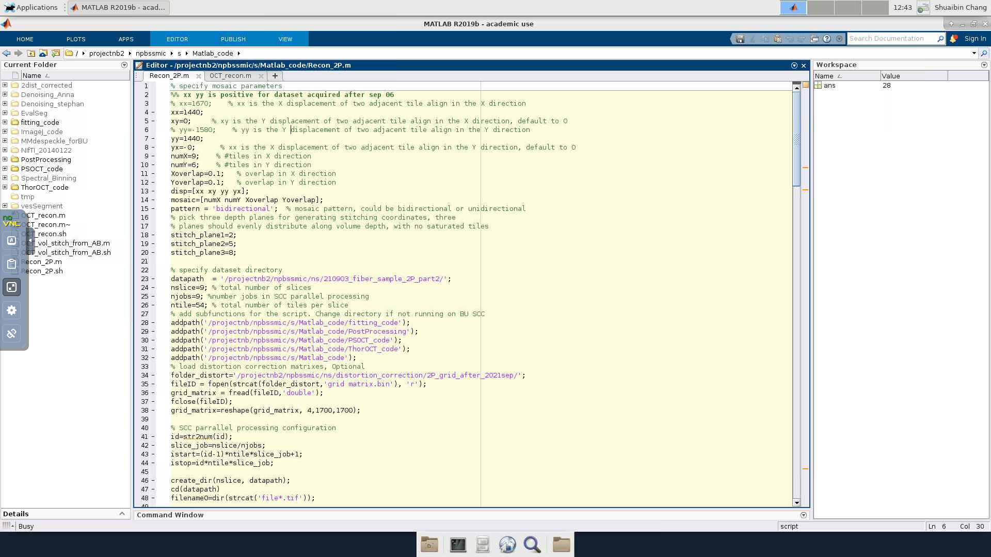

2P file path, #slices, #tiles per slice and njobs for parallel processing, change for each sample

Load grid distortion correction matrix, leave unchanged unless alignment is changed

mosaic param, change numX, numY for each sample

3 planes used for generating stitching coordinates, change for each sample

SCC parallel processing part

1. **Multi-thread using BU SCC**

Shared Computing Cluster(SCC) is a remote storing and computing facility in BU. For SSOCT project we use SCC to store data as well as performing post-processing tasks. Multi-thread processing is achieved by separating the data into a couple of portions(usually one slice per portion) and running the same code for each portion. Hence, identification of which portion to process within the code is needed.

*id=str2num(id);* then use id to separate data. For details refer to the SCC parallel processing code

1. **Distortion correction**

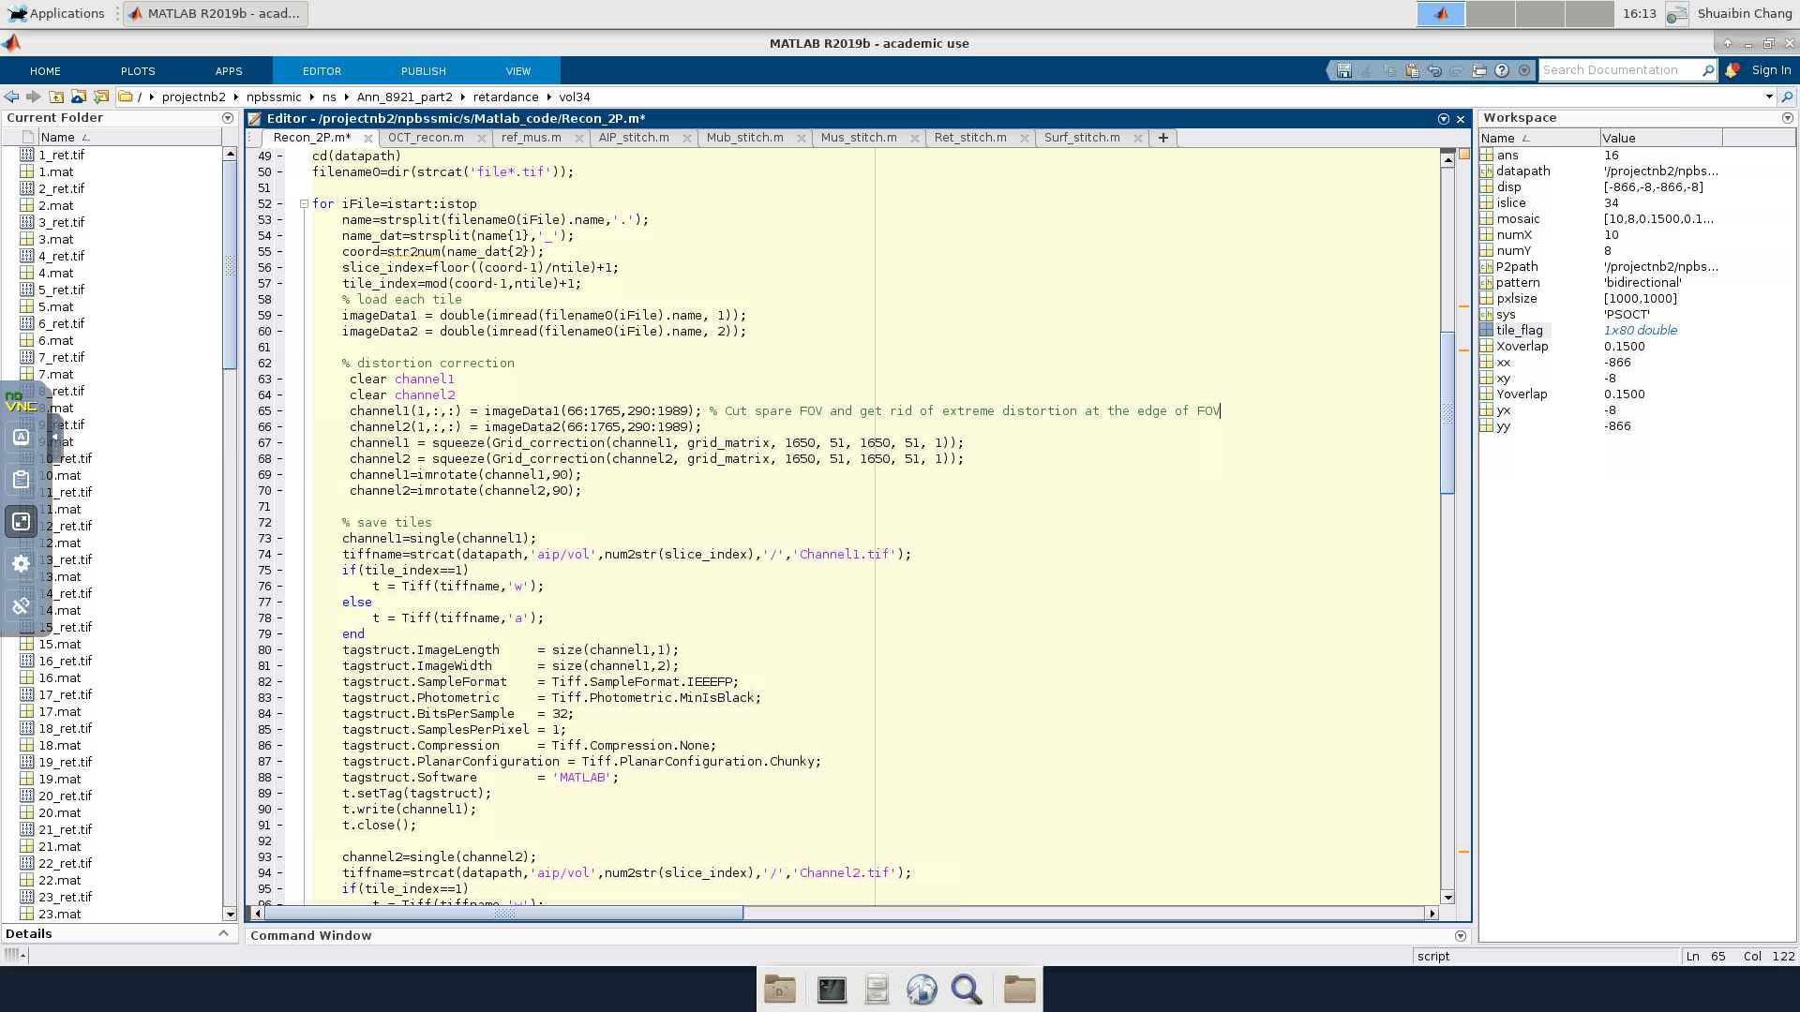

Load 2P tiles and distortion correction, nothing should be changed unless alignment changed

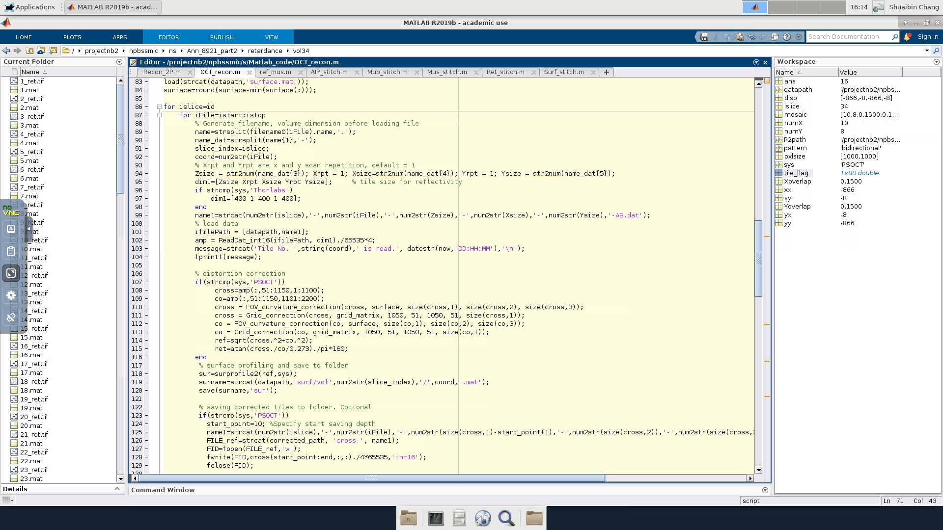

Save corrected data into binary files, change start_point for each sample

Surface profiling

Load PSOCT tiles and distortion correction, nothing should be changed unless alignment changed

Optical microscopes will always introduce more or less distortions to the image. When stitching tiles, distortion correction is needed to make the images artifact-free. Distortion correction is separated into two steps, first step corrects the z dimension distortion using *FOV_curvature_correction.m* and the second step corrects the XY plane distortion using *Grid_correction.m*.

A glass sample is imaged prior to the sample imaging and the surface profile of the glass sample is extracted. The extracted surface is saved as a lookup table for correcting the z dimenstion distortion of each pixel. Alternatively, you can sum all tiles from a slice and use the averaged surface as the curvature. This worked well when #tiles is more than 100.

To pre-measure curvature using glass slide, take an image of the glass slide using GPU FFT and single channel, run Find_FOV_Curvature.m, file is on SCC. To generate curvature from averaged tiles, uncomment Hui_sum_all(datapath, ntile,1) in OCT_recon.m line 86. Either way, a surface.mat file will be generated. Put it in the folder of new data on SCC if it’s not there.

A Thorlabs grid target is also imaged prior to the sample imaging. The image of grid pattern is registered to a perfect grid pattern generated in MATLAB using bUnwarp(ImageJ). The registration provides the unwarp matrix which is used for grid distortion correction of sample images.

To generate grid correction matrix after re-alignment, take an image of the 100um space grid pattern using GPU FFT single channel. First run Find_FOV_Curvature.m to find curvature, then run Find_Grid_Distortion.m. Load grid.tiff to imagej, measure the XY position of the grid center, rotation angle and X, Y length (in pixels) of 1 grid. Use these as parameters to run Generate_undistorted_grid_pattern.m. Note that X dimension is imagej is Y dimension in Matlab, and vice versa. Once the undistorted.tiff is generated and it has relatively same shape as the grid.tiff, drag the macro.ijm generated by Generate_undistorted_grid_pattern.m and click run. If registration success, run Generate_grid_matrix.m with the folder specified as where the grid.tiff locates. This will generate a binary file enclosing the transformation matrix of the grid distortion correction. Use the path where the “grid matrix.bin” locates as the folder_distort in line 57 of OCT_recon.m

1. **Surface profiling**

Surface flatness is one of the quality controls of SSOCT project. For each tile we will find the surface height using *surprofile2.m*. The surface of each tile will be stitched later and serve as the vibratome performance control.

1. **Optical property fitting**

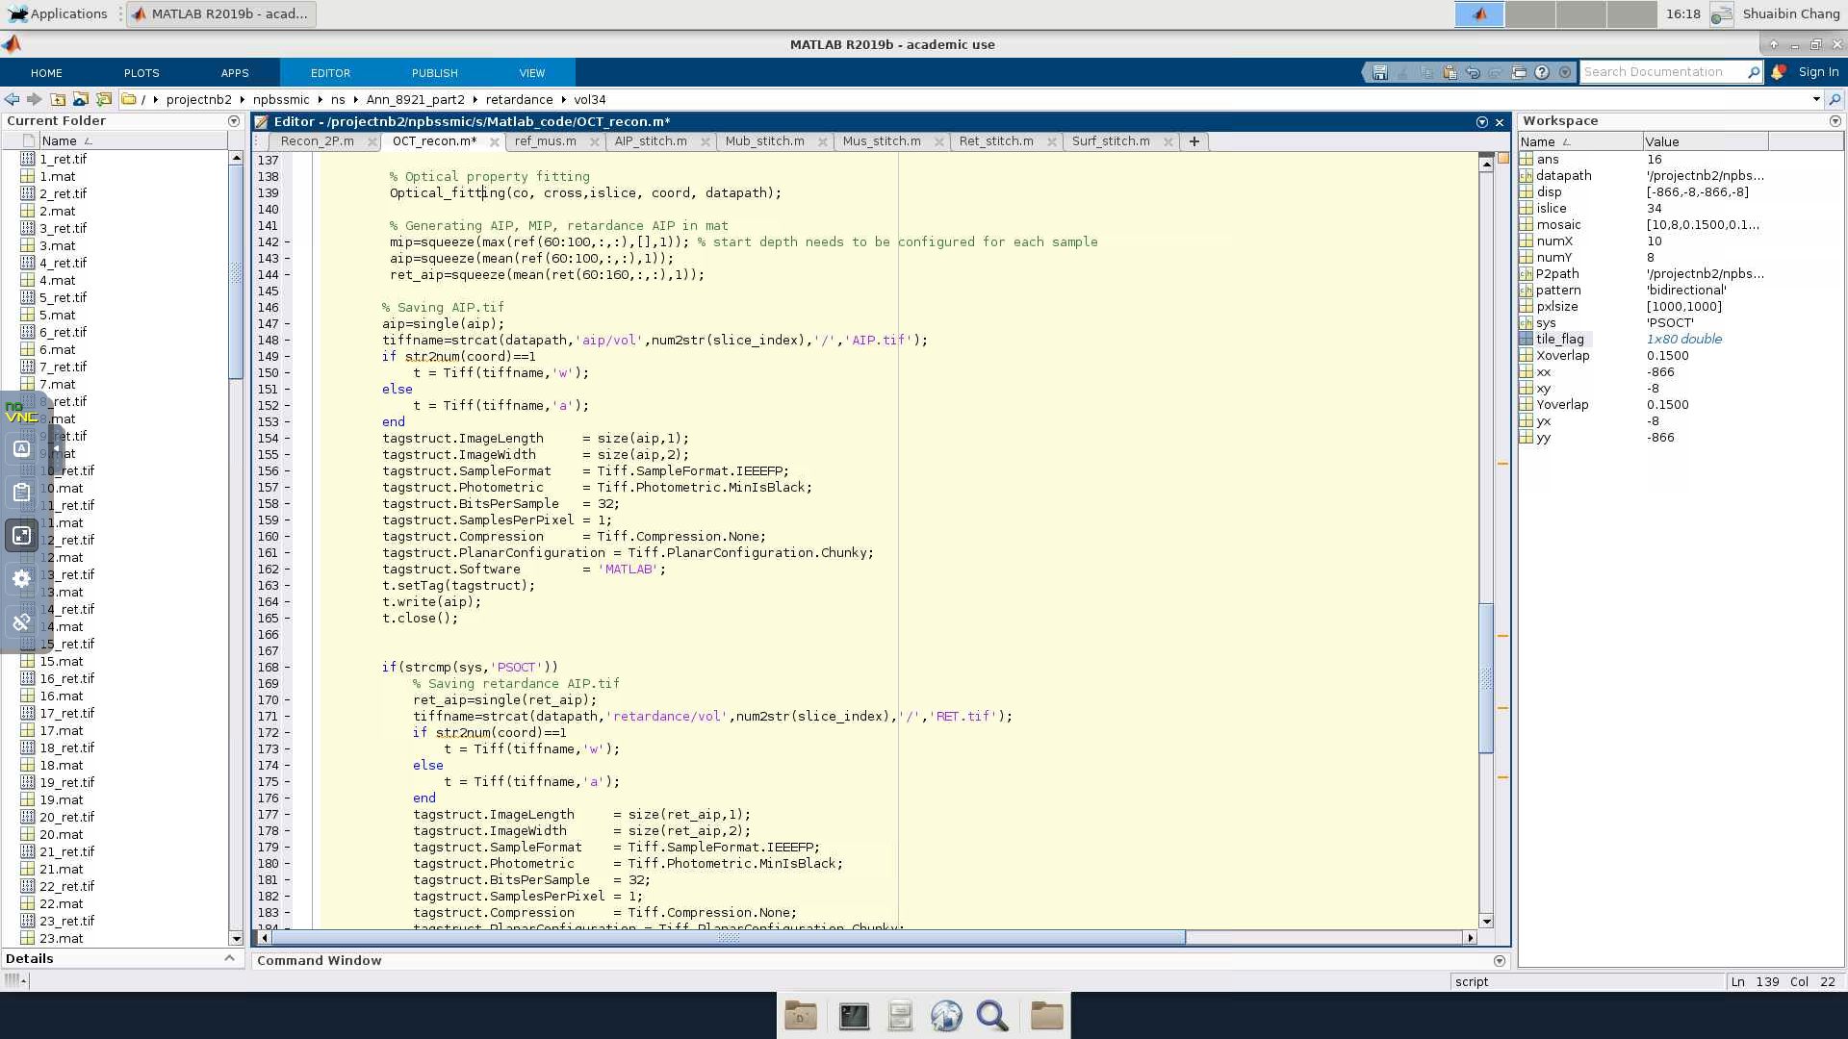

Save AIP, MIP, retardance of PSOCT. Start point needs to be changed for each sample

Optical property fitting, including scattering model and birefringence model. For fitting birefringence in index-matched sample, use Optical_fitting_TDE.m

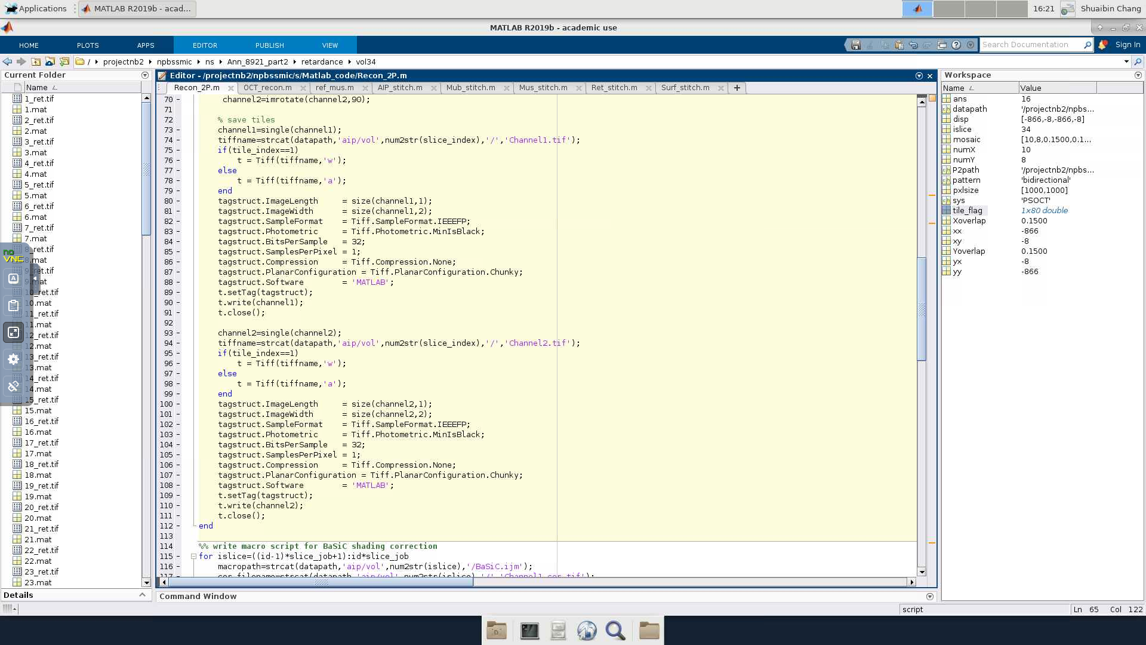

Save two channels of 2P. nothing should change here

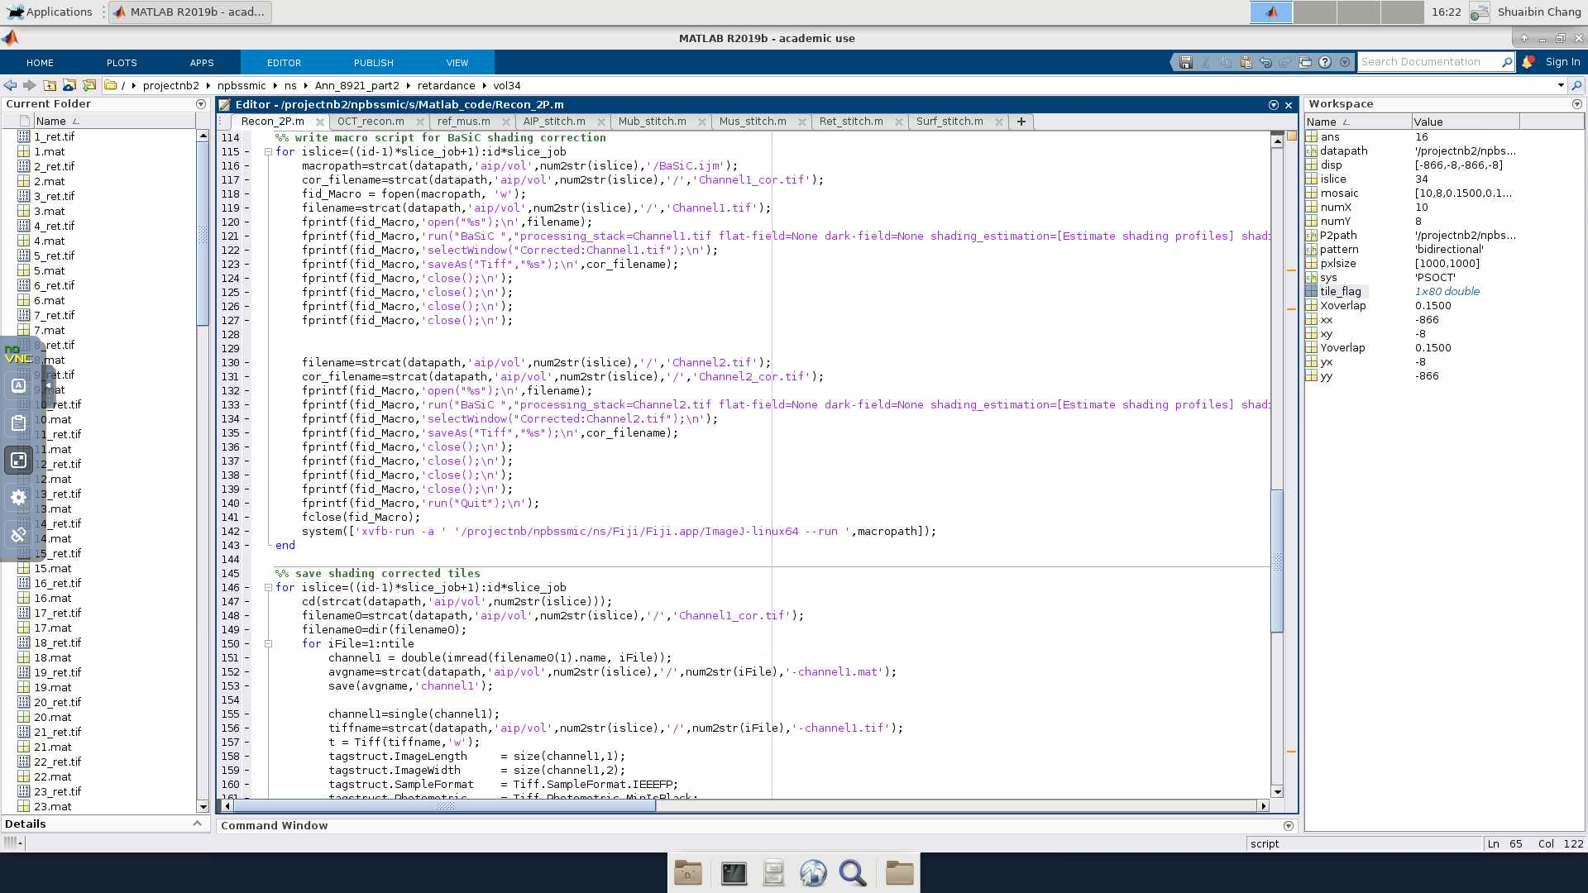

This whole part does shading correction of 2P images using BaSiC algorithm. Nothing should change here

Scattering coefficient and back-scattering coefficient are useful optical parameters to characterize the sample properties. We use a non-linear model to fit the A-line profile of OCT signal and extract the optical parameters[1]. The fitting procedure is packaged into *Optical_fitting.m*. For TDE sample, use Optical_fitting_TDE.m. The difference between these two codes is that in Optical_fitting_TDE.m it uses sine and cos function to fit cross and co polarization, while in Optical_fitting.m it uses linear function to fit cross and co polarization, as depth profile in non-TDE sample only show linear trend.

1. **Shading correction**

We use BaSiC shading correction algorithm, it can be called in Imagej and there’s a MATLAB function. Here we use Imagej functions. For details refer to <https://www.helmholtz-muenchen.de/icb/research/groups/marr-lab/software/basic/index.html>

1. **2D images stitching**

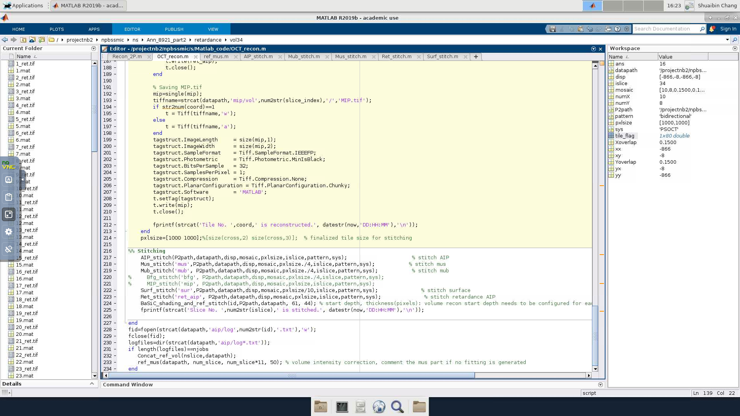

PSOCT 3D volume stitching

PSOCT 2D images stitching

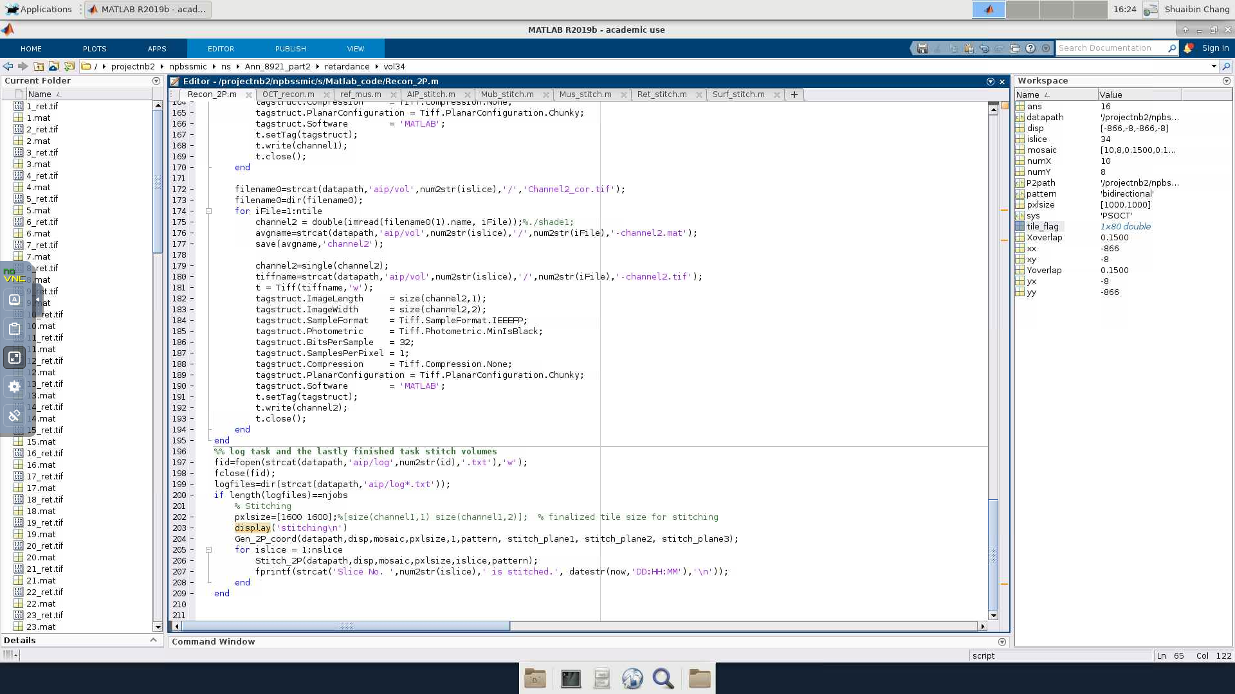

2P 2D images stitching

2P has higher resolution and no speckle noise, so stitching 2P tiles gives more precise X and Y coordinates for each tile. Utilizing this fact, we pick 3 slices of the 2P images, ideally span across the depth, combine them into RGB images and stitch the R,G,B channels simultaneously, giving optimal X and Y coordinates for all slices. We scale the coordinates of 2P to stitching OCT. The scaling ratio is *2P pixel size/OCT pixel size*. AIPs of each tile are stitched together using *AIP_stitch.m*. Similarly, we stitch surface (*surf_stitch.m*), retardance (*ret_stitch.m*), MIP (MIP_stitch.m) and mus and mus (*mus_stitch.m, mub_stitch.m*), retardance (Ret_stitch.m), fitted birefringence (bfg_stitch.m) if they are generated. Note that the coordinates need to be down-sampled by the same factor as mus and mub (4 if default) when stitching them.

1. **3D volume stitching**

The same coordinates are also used for volume stitching (BaSiC_shading_and_ref_stitch.m). The filename shows shading correction is also implemented for volume.

1. **Vessel segmentation**

Vessel segmentation is not included in the OCT_recon.m, you can find it on SCC: Matlab_code/vesSegment.

The process of vessel enhancement can be generally viewed as a filtering process that searches for geometrical tubular structures. Since vessels appear in different sizes, it is important to incorporate an adjustable scale of the filter which can vary within a certain range. A common approach to analyze the local behavior of an image, $I\left(x\right)$, is to consider its Taylor expansion in the neighborhood of a point $x_{o}$,

$$I\left(x_{o}+δx_{o},σ\right)≈I\left(x_{o},σ\right)+δx_{o}^{T}∇_{o,σ}+δx_{o}^{T}H_{o,σ}δx_{o}$$

The expansion equation above approximates the local structure of the image up to second-order derivatives. $∇_{o,σ}$ and $H_{o,σ}$ are the gradient vector and Hessian matrix of the image computed at $x_{o}$ at scale $σ$. To calculate these differential operators of $I(x)$ in a well-posed fashion we adopt concepts of linear scale-space theory. In this framework, differentiation is defined as a convolution with derivatives of Gaussians:

$$\frac{∂}{∂x}I\left(x,σ\right)=σI\left(x\right)*\frac{∂}{∂x}G\left(x,σ\right)$$

Where the D-dimensional Gaussian is defined as:

$$G\left(x,σ\right)=\frac{1}{{\left(2πσ^{2}\right)}^{D/2}}e^{-\frac{{\left\|x\right\|}^{2}}{2σ^{2}}}$$

The third term in Equation (2.1) gives the second order directional derivative,

$$δx_{o}^{T}H_{o,σ}δx_{o}=\left(\frac{∂}{∂δx_{o}}\right)\left(\frac{∂}{∂δx_{o}}\right)I(x_{o},σ)$$

The idea behind eigenvalue analysis of the Hessian is to extract the principal directions in which the local second order structure of the image can be decomposed. Let $λ_{σ,k}$ denote the eigenvalue corresponding to the k-th normalized eigenvector ${\hat{u}}_{σ,k}$ of the Hessian $H_{o,σ}$ all computed at scale $σ$. From the definition of eigenvalues:

$$H_{o,σ}{\hat{u}}_{σ,k}=λ_{σ,k}{\hat{u}}_{σ,k}$$

and it follows that

$${\hat{u}}_{σ,k}^{T}H_{o,σ}{\hat{u}}_{σ,k}=λ_{σ,k}$$

The eigenvalue decomposition extracts three orthonormal directions which are invariant up to a scaling factor when mapped by the Hessian matrix. In particular, a spherical neighborhood will be mapped onto an ellipsoid whose axes are along the directions given by the eigenvectors of the Hessian and the corresponding axis' semi-lengths are the magnitudes of the respective eigenvalues. This ellipsoid locally describes the second order structure of the image and can be used as an intuitive construct for the design of geometric similarity measures. We assume $λ_{k}$ to be the eigenvalue with the k-th smallest magnitude ($\left|λ_{1}\right|≤\left|λ_{2}\right|≤\left|λ_{3}\right|$) in this work.

In general, a pixel is considered to belong to a vessel if two conditions are met: (1) $λ_{1}$ being small (ideally zero); (2) $λ_{2}$ and $λ_{3}$ of a large magnitude and equal sign (the sign is an indicator of brightness/darkness). The respective eigenvectors point out singular directions: ${\hat{u}}_{1}$ indicates the direction along the vessel and ${\hat{u}}_{2}$ and ${\hat{u}}_{3}$ form a base for the orthogonal plane. In PSOCT images, vessels show up as dark tubular vacuum compared to brighter surrounding tissue. In this work, we adopt a similarity measure to a tube:

$$ω=\left\{\begin{aligned}\left|λ_{3}\right|{\left(\frac{λ_{2}}{λ_{3}}\right)}^{γ_{23}}{\left(1+\frac{λ_{1}}{\left|λ_{2}\right|}\right)}^{γ_{12}} , λ_{3}<λ_{2}<λ_{1}≤0 \\ \left|λ_{3}\right|{\left(\frac{λ_{2}}{λ_{3}}\right)}^{γ_{23}}{\left(1-α\frac{λ_{1}}{\left|λ_{2}\right|}\right)}^{γ_{12}}, λ_{3}<λ_{2}<0<λ_{1}<\frac{\left|λ_{2}\right|}{α} \\ 0, otherwise\end{aligned}\right.$$

Where $γ_{23}≥0$ and $γ_{12}≥0$ controls the selectivity of the filter, and $0≤α≤1$ introduces asymmetrical behavior of the filter in the negative and positive regions of $λ_{1}$. In practice, we found $γ_{23}=γ_{12}=0.5$ and $α=0.25$ generally work well with volumetric PSOCT data

1. **How to run them?**
2. Run Recon_2P.m first. Put the correct file path, numX, numY, stitch_plane#, nslice. The three stitch_planes should evenly distribute along volume depth.
3. In terminal, qsub -t 1-nslice Recon_2P.sh
4. After Recon_2P.m is finished, run OCT_recon.m
5. Put the correct datapath (OCT data path), P2path (2PM data path), nslice, numX, numY. Set id=1 and run the code in MATLAB. The first run will execute line 83: Hui_sum_all(datapath,ntile, 10,300), which generates the surface curvature profile. In this function, parameters are datapath, ntile, slice#, Z pixels. slice# should be the one that was cut even. The first couple slices are not evenly cut because some region is still underneath agarose, so pick a medium slice.
6. After Hui_sum_all() finishes, keep running until line 135. The start_pixel needs to be fine-tuned for each dataset. The value should be 5-10 pixels beneath the surface.
7. Then you should also check line 147, where it differentiates tissue from agar by mean and std. Make sure the threshold is effective for the differentiation.
8. In terminal, qsub -t 1-nslice OCT_recon.sh
9. If you want to fit optical properties, run Fitting_after_recon.m
10. Put the correct folder (OCT data path), P2path, ntile, nslice, numX, numY, ds_factor. ds_factor is the downsample factor, default is 10.
11. In terminal, qsub -t 1-nslice Fitting_after_recon.sh